**Lab 3 – SQL**

**Each problem is worth one point. No partial credit will be given. This lab is worth a total of 15 points.**

**From this lab forward, please notice if a result table is in a particular order. If it is you must use the order by clause. Failure to do so will result in 0 points for that specific problem.**

**Place all answers into ONE .sql file and upload to Canvas.**

**\*\*\*\* Use the OM table space for the following questions \*\*\*\***

**1. Display customer’s last name in alphabetical order. Use the Customers table.**

**Partial result table (25 rows total)**

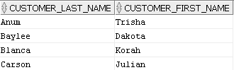

**2. Display customer’s last name in descending order. Use the Customers table.**

**Partial result table (25 rows total)**

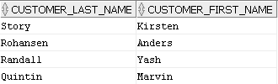

**3. Display customer’s last name in ascending order and their first name in descending order.**

**Use the Customers table.**

**Partial result table (25 rows total)**



**4. Display customer’s last name in descending order using a column number. Use the**

**Customers table.**

**Partial result table (25 rows total)**



**5. Create the following result table exactly. Notice the column names. Use the Customers**

**table.**

**Partial result table (25 rows total)**

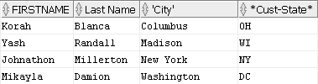

**6. Display each state only once. Use the Customers table.**

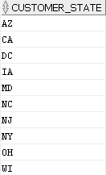

**7. Display each fax number value only once. Use the Customers table.**

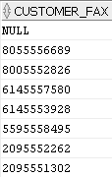

**8. Display the first 4 rows only in the customers table. Use the Customers table.**



**9. Display any song titles that contain the word “road”. Use the Items table.**



**10. Display any song titles that have a decimal point in the unit price of that song. Use the**

**Items table.**

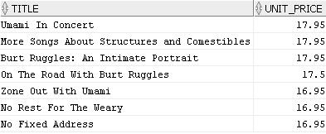

**11. Display any song titles that do not have a decimal point in the unit price of that song.**

**Use the Items table.**

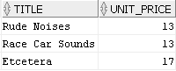

**12. Display all orders that have at least an order quantity of 2. Use the Order_Details table.**

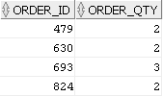

**13. Display all order id’s divisible by 13. Use the Order_Details table.**

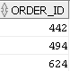

**14. Display all orders with no shipped date. Use the Orders table.**

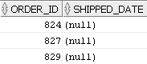

**15. Display the number of days from when the order was received to when the order was**

**shipped. Only include at least 25 days and above in your result table. Use the Orders**

**table.**

